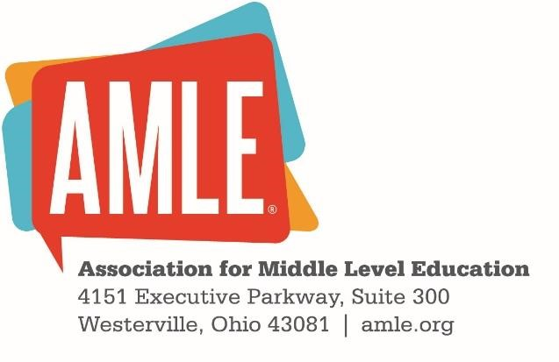

Middle School Journal Parent/Guardian Consent Form

I grant permission for my child’s writings to be used in digital form and in print solely for the purposes of the Middle School Journal. I understand that excerpts from this may be used in future projects with the Association for Middle Level Education, in promotional materials for the journal, on AMLE websites, and in other print and digital formats. I waive any rights of compensation or ownership thereto.

If the child is under 18, I certify that I am his or her parent or legal guardian and I give my consent without reservation to the foregoing on his or her behalf.

Child's Name (printed) ________________________________________________________
Parent's/Guardian's Name (printed) _______________________________________________
Parent's/Guardian's Signature ____________________________________Date ____________
This completed consent form should be uploaded with the corresponding manuscript and cover letter at www.editorialmanager.com/msj

