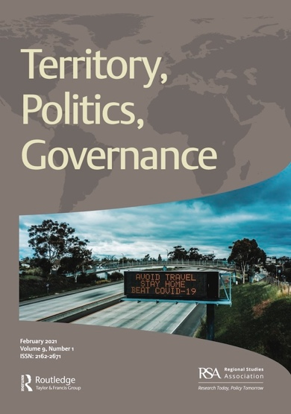

Territory, Politics, Governance
Special Issue Information Sheet

Please complete all fields with as much detail as possible and
email the completed form to RTEP-peerreview@journals.tandf.co.uk
Overview
Proposed title
Subject areas
How does the special issue contribute to current debates and research?
How does the special issue fit the aims of the journal?
Is the issue based around a conference or seminar? Please provide details.
How will the range of contributions result in a strong collection?

Guest Editor information
Principal Guest Editor’s name, affiliation and email address
Co-Editor names, affiliations and email addresses

Further information
Number of papers expected
If authors have not already been secured, do you require a call for papers? If so, for what dates?
Deadline for authors to submit their papers to the journal for selection / peer review
Would there be opportunities to disseminate the special issue at particular events?
Are there any “hot” topics or papers that would benefit from additional dissemination?

Proposed papers (expand as required)
No. | Authors, affiliations and email addresses | Title and abstract (max. 150 words for abstract; to be shortened to 100 words on paper submisison) | Potential referees (3 per paper) with affiliations and email addresses. N.B. Special issue authors and Guest Editors do not normally qualify as referees for other contributions.
1
2
3
4
5
6
7
8
9
10

